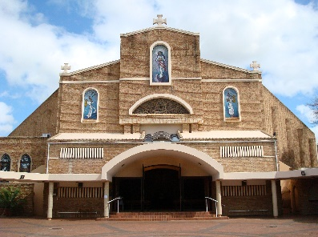
No.

for office use only

PARISH OF THE IMMACULATE

CONCEPTION PINETOWN

DEDICATION OF FINANCIAL RESOURCES

Complete dedication form & return to the office
Section A: Personal Details
Husband / Mr
First Name______________________ Surname: __________________________
Contact: (H)_______________ (W) _______________ (C)____________________
Email Address: _______________________________________________________
Address: ____________________________________________________________
____________________________________________________________

Wife / Miss
First Name______________________ Surname: ___________________________
Contact: (H)_______________ (W) _______________ (C)____________________
Email Address: _______________________________________________________
Address: ____________________________________________________________
____________________________________________________________

Section B: Pledge Details
Lord God, in gratitude for your generosity, I/we pledge the amount of: ____________
FREQUENCY
Weekly
Monthly
Annually
Please choose one of the following three payment methods. It is preferable that contributions be made electronically or via Debit Order, if possible, rather than in cash, for security reasons.
METHOD OF PAYMENT
Monthly Debit Order (relevant forms will be sent to you for completion)
Monthly Envelope
Electronic Payment (EFT)

“I have a treasure from the Lord’ – 2 Corinthians 4:7

