-------+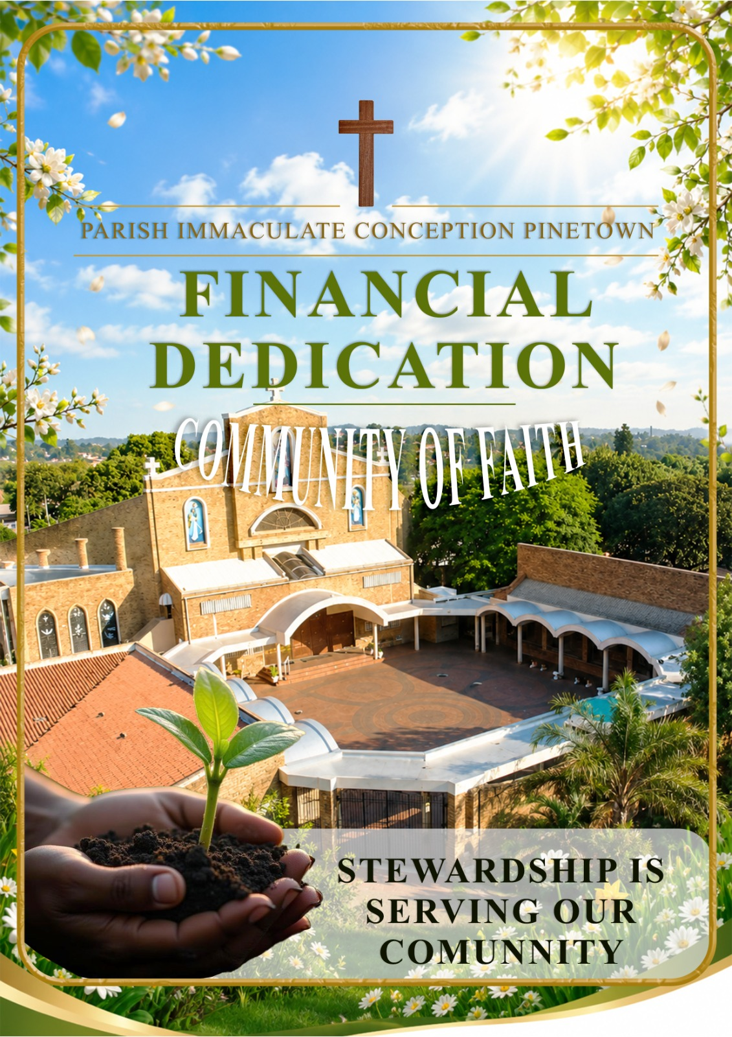

Financial Dedication

Why is the Church always talking about money?
or should that be:
Is the Church always talking about money?

Some Catholics complain that the Church is always talking about money even though this is only addressed once during the year when we are asked to renew our Yearly Financial Dedication. Realistically we must accept that, like every other institution or organisation, the Parish needs money to exist, to support itself, |  | An to continue its ministry and service. As we have seen over the years we have been asked to support St. Vincent de Paul, Feeding Poor, the Lenten Appeal, Advent Appeal for the Archdiocese, Archdiocesan monthly Levy and the Mission Sunday Collection in October for the Universal Church.

The Church: Our Spiritual Home
The Parish: Our Spiritual Family

The parish is a family and the Church a home for all God’s children. As we all know, maintaining a family and running a home has its own special problems and challenges, not least of which are the financial considerations. Good and responsible parents know that the finances can be managed by intelligent planning and careful budgeting. |  | Dedicated Planned Giving is a tried and tested method of planning diligently the budget for our spiritual family and our spiritual home. In this way we support ourselves, one another, invest in our faith and ensure that the Gospel is proclaimed as effectively as possible.

‘God loves a cheerful giver’ 2 Corinthians 9:7 At times in our lives we might find ourselves compelled to do certain things without it being from the heart. One needs to come to a realization that when it comes to the things of God, it has to come from the heart so as to be blessed in abundance. What come out clearly from this text is that it is a free choice, you do not give if you do not see the need to do so. Secondly there is no pressure, if you feel that there is no need it’s better not to do it, but if you understand what is going on, then it needs to happen. Thirdly there should be joy when one does this.
In the past few years, we have come to understand that dedication is not just financially, but goes further to dedicating our time and talent as well. There are so many skills that people possess which would be of benefit to the Church had they been offered to the Church. Those talents though are connected with the issue of time as to whether the Church is so important to me that I would make time to assist. This is over and above coming to Mass on Sunday and other liturgical celebrations. This is intentionally setting aside time to do other activities of the Church, especially those ones which require me to take off sometime from work even for me to be able to do them. Bearing in mind at the end of the day that it all should be done joyously.

Common Questions about Financial Dedication

Why does the Church need money?  Because everything costs - from the bread and wine used at Mass on Sundays; to the usual household expenses such as electricity, water, refuse removal, telephone; the salaries paid to parish employees. All these form part of the budget for the next financial year.    Necessity of having full time employed people.  As the work of the Church progresses there is lot of work that needs to be done, which can be a bit too much for one person. It is for that reason that the Parish has employed currently five people to assist. This includes the admin work, keeping financial records. Maintenance of property. For now, we do not have anyone employed for catechetical formation as we solely rely on those who have dedicated themselves to assist with Catechism.  The shortage of priests and Religious brothers and sisters mean that those who are available are spread even thinner. |  | Does the parish receive any outside or other income?  No. All our income is generated within the parish. Immaculate Conception Parish is a self-supporting parish and therefore we have to take care of our own needs.    Does the parish priest benefit from increased financial resources?  No! All Diocesan Priests, regardless of where they work, receive the same monthly salary. They are more or less responsible for their own personal material well-being. As a general rule though the Parish is responsible for its own Priest.  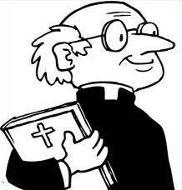  Who pays the priests’ salary?  In self-supporting parishes, like Immaculate Conception Parish, the priests’ salary is paid by the parish. The Archdiocese pays the salaries of priests in non-self supporting parishes. Hence the importance of Diocesan Levy.  Do we support any other parishes?  Not directly. Like every parish in the Archdiocese, we pay a monthly Diocesan Tax (28% of our monthly income). In this way the Archdiocese is able to take care of itself and also to support those parishes that are not able to support themselves.

Common Questions about Financial Dedication
Is Diocesan Tax the only source of income for the Archdiocese?  Thankfully not! At present the Archdiocese still relies heavily on overseas donations. A good percentage of the income of the Archdiocese is made possible through the generosity of Catholics overseas. Every year sees a significant decrease in this form of income presenting a greater challenge to this local Church to support itself.  The Church in Southern Africa has committed itself to become 15% more self- reliant but the current economy has made this a difficult challenge. We hope that through the process of Christian Stewardship all parishes in our Archdiocese will become less reliant on the generosity of overseas donors.    Who administers parish income and expenditure? Is it the parish priest?  While Fr. Zithulele, in his capacity as parish priest, oversees all parish administration including income and expenditure, he is, like all Parish Priests, bound by the Code of Canon Law and Diocesan Statutes to appoint a Finance Committee to assist in the administration of parish finances. The members of this Committee are: Ian McMurray, Nomalungelo, S’bu Sibisi, Mbalenhle Dlamini, Deacon Trevor Kondiah. |  | What about accountability?  The Finance Committee answers to the Parish Pastoral Council. In addition, the parish is required to submit a half-yearly statement to the Financial Administrator of the Archdiocese. A monthly statement of income and expenditure is available to all parishioners after Finance Committee meetings and Ian is available to respond to queries.    Why should I give money to the Church?  The primary reason for giving is to demonstrate, in a very real and tangible way, our faith and trust in God. We are called to put Him first in our lives, and that includes our financial commitments. When we give sacrificially, we demonstrate our trust and dependence on God in every area of our life, beginning with our money. In addition, our giving supports the work and ministry of the Church from which we, in turn, benefit. Most important of all, we are responding to the abundant generosity of God.  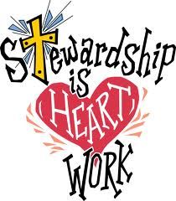

Common Questions about Financial Dedication
Why should I pledge?  Can I not give as I wish through  the Sunday collection?  A pledge is a commitment. It enables you to make a dedication to God. You are also able to plan properly and this makes it possible for the parish to do the same. Like any household or business, the parish has to budget. In this way the parish is able to keep a control on expenditure, as well as ensuring that there is an adequate income to meet this expenditure. Imagine if your monthly salary was entirely dependent on what your employer chose to give you at the end of each month!    How much should I give?  Tithing (the dedication of 10% of your gross salary to the Church) is the fundamental concept and basic principle of most Christian churches. Tithing has a strong Biblical basis, especially in the Old Testament. This was the common practice of the people of Israel. It is a way of acknowledging God as the giver of every blessing received and promised. Similarly the dedication made in the parish is a thanksgiving for God’s work though the parish and in support of the work of the Church from which we all benefit.  Although tithing is the general practice in Christianity today, the Catholic Church |  | does not impose this upon her members. It is a practice that is encouraged! If you are not tithing then it would be a good exercise to work out exactly what percentage of your gross salary you are dedicating to God through his Church. The following table should help:  Gross salary : R_________  10% of gross salary : R_________  2% of gross salary : R_________  1% of gross salary : R_________  0.5% of gross salary : R_________  My monthly dedication : R_________  Each person has to make a personal decision about their monthly dedication but this needs to be done in a spirit of generosity and commitment. That is why it is called a Dedication. It has more to do with our spiritual attitude and commitment than with Rands and cents (although the Rands and cents are important to sustain the infrastructure which provides the spiritual).  

Common Questions about Financial Dedication

What does the Parish need from you to meet its Budget for the next 12 months?  For our next financial year 2027, we will need a minimum of R 234 000 to meet our Budget. On average this would work out to about R500 per family or individually per month.  For many of Immaculate Conception parishioners, however, this is well within our means. At the end of the day though it depends on how we view dedication. Do we see it as an obligation or do we see it as a burden.  What about students and others who are not wage earners?  All those who avail themselves of the services provided by the Parish should make a contribution. Students contribute according to their allowance and/or pocket money. We are hoping that there will students who will take this upon themselves to see to it that they contribute to the well-being of the Church  Which method of dedication is preferable: the Envelope System or Electronic Banking or Debit Orders?  The parish indicates no specific preference. It has been proved, however, that Electronic Banking and Debit Orders are a more reliable source of income as it eliminates the forgetfulness factor. This form of dedication also ensure that the amount of cash handled by the parish is reduced. Given the current crime wave in our country we would naturally prefer to handle as little cash as possible. The choice, however, is yours.  What about confidentiality?  With the exception of Carmel who administers Dedicated Planned Giving, no other members of the parish or the |  | administration staff have access to the amount you dedicate. While your dedication is essentially between you and God, it does have to be administered by someone. Your dedication is treated with the strictest confidence and is received on trust.  What if I’m unable to live up to my Dedication?  Changes and adjustments can be made at any time during the year. Nobody is compelled to rigidly observe the amount originally dedicated. As circumstances change (for better or worse) so your Dedication can be adjusted. Carmel will be happy to make such changes - if she is informed.  How do I make my dedication?  Complete the necessary details on the Financial Dedication Form which you received with this booklet (forms are also available via email, from the parish office or at the back of the church).  How do I return my Dedication Form?  Your completed form should be returned during the month of September, (preferably) in an envelope or folded to ensure strict confidentiality. After your details have been processed, a dedication number will be allocated to you (if this has not been done already). Envelopes will be provided for those who prefer to use the monthly/weekly Dedication Envelope and Debit Order Dedications will be processed by the parish.

Where does all the money go?  We have listed the following areas of expenditure:  - Catechetics: All resources for the parish’s catechetical programme including books, material, and on-going formation for catechists.    - Church Expenses: All that is required for the daily celebration of Mass including hosts, Mass wine, vestments, books, flowers, candles, music, and the cleaning of the church.  - Diocesan Tax : Diocesan Tax is used to run the Church as well as to sustain non-self supporting parishes. We currently pay 28% of our monthly income in Diocesan Tax.  - Donations: Occasionally there is a request from the Diocese for support of particular causes. These often come on top of other requests and financial campaigns. This fund will be drawn on to prevent repeated financial requests of people.  - Electricity & Water: for the Presbytery, parish office, halls and church.  - Formation: The development of Lay Ministries, which is a priority in our  parish, requires on-going training  and formation. As local resources  17. Printing & Stationery: this  includes all printing,  photocopying, paper, booklets,  handouts and notes.  18. Repairs & Maintenance: All  repairs and maintenance to the  presbytery, offices and church  buildings, gardens and general  upkeep.  19. Repository: Purchase of all stock  for the repository which includes  all publications.  20. Security: Alarm monitoring and  response as well as security at the gate at all times. |  | need to be done, especially now that Immaculate Conception has existed for the past 41 years and it needs overhauls on a number of things  - RCIA: With the continued growth of  this very special area of formation we need to provide adequate and current resources. This extends to materials, handouts and reading material for the Candidates and Catechumens.  - Functions: This covers the  Sunday teas as well as other functions such as those of the deanery and Diocesan meetings and functions etc.  - Insurance: Buildings, contents, equipment, motor vehicles.  - Medical Aid: for the parish  priest.  - Motor Expenses:  Fuel and repairs and  maintenance for the parish cars.  - Office expenses: Bank charges,  petty cash, maintenance of  computers and equipment,  replacement of consumables.  - Parish Discretionary Fund:  Used at the discretion of the  Parish Priest and/or the Finance  committee, primarily to assist  those in need.  - Pension: a percentage of  earnings for 5 employees and  the Parish Priest.  - Software Systems: To maintain an  online presence and parish  administration  16. Presbytery Expenses: Upkeep of  the presbytery, groceries, cleaning  material and running expenses.  21. Stipends: Paid to visiting priests  who assist at Masses during  Father’s absence, for assistance at  Penitential Services and other  special celebrations.  22. Telephone: All outgoing calls  including line and switchboard  rental.  - Salaries: 5 staff as well as the parish priest.  - Youth: for non-catechetical youth activities and functions.  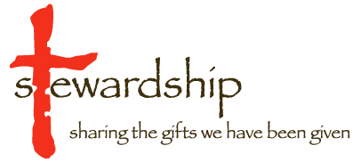

Allocation of Financial Dedications
- Car replacement: contingency for the replacement of parish vehicle. |  | - Savings: Funds invested with the  Archdiocese.

Income
- Catechetics : Total received from the annual Catechism registration fees.  - Plate Collection: Cash from the Sunday Collection.  - Dedicated Planned Giving:  Parishioners’ dedications.  - Repository: Received from repository sales as well as publications such as Southern Cross, Living Faith.  - Stipends: Offerings for Masses |  | - Stole Fees: Weddings, Funerals and Baptisms.  - Sundry Income: Donations.  - Interest: On funds invested  